Process Definition Document v 1.0.1
Automation of Acme Transaction Requests Checking
Commissioned by Leading Business Improvement
Development by BA Team
Date: 30/8/2025
Statement of confidentiality
This document contains information that is proprietary and confidential to Raya It, which shall not be disclosed, transmitted, duplicated, or used in whole or in part for any function other than its intended purpose. Any use or disclosure of whole or in part of this information without explicit written permission of Raya It is prohibited.
© Copyright, Raya

Table of Contents
1. Objective 3
1.1. Business Objectives and Benefits 3
2. Current Process 3
2.1. Process Overview 3
2.2. Standard of Metrics 4
2.3. Volume of data 4
3. Business Rules 5
4. Detailed Process Steps – AS IS 5
5. To-be Pre-process steps (Proposed solution) 6
6. In Scope 6
7. Out of Scope 7
8. Non-process requirements 7
8.1. Systems 7
8.2. Reporting 7
8.3. Archiving 8
8.4. Security & data retention 8
9. Appendix 8
Open Questions 8
Escalations 8

Objective
The objective of this work is to deliver an automated solution to the current invoice Review of academy system. This solution will seek to deliver a process to be Tended partially which needs human interaction when error happens, the look for Translation and check for client id and extract balance will be a significantly faster process turnaround time. The solution will look to operate seamlessly in the process, triggering off other parts of the process, notifications and calls to action. Based on the needs of the business, the objective of this work is to deliver an automated solution which improves the efficiency, effectiveness and productivity of this process and its outputs.

1.1. Business Objectives and Benefits

Objectives | Expected Benefits
Deliver faster processing | Produce faster calculation of balance account
Reduce duration of time-consuming activities | Reduce time for extracting and review data manually
improve the department`s overall performance and reliability. | Reduce human error by mis calculation and copy something wrong

Current Process

2.1. Process Overview
When new Transaction is added on system Accounts Payable should open transaction record on acme system 3 then extract client id and amount, he wants to withdraw then open acme system 3 and search for client by id and check if its balance allows this kind of transaction or not, then update Transaction Record either rejected or completed

2.2. Standard of Metrics

General information about the process selected for RPA, prior to automation:

Process name | Transaction Request Validation
Function | Accounts Payable
Department | Finance and Accounting
Process short description | Accounts Payable check if current Transaction Request can be executed or not
Process schedule | Daily, Monday to Friday, 9 am – 6 pm
#of items process/month | ~4500
Average cycle time | One business day
Average handling time | 10 M/ Transaction
Peak period(s) | End of month, usually from 20th to 28th day of each month
# of FTE supporting this activity | 1
Input Data | Transaction Record(Client id,Account Number, Account Balance)
Output Data | Total Balance Extracted Transaction Record Statue updated
Return on investment | Reduce Time needed by Each Transaction and reduce Human Error makes it comes to Zero

2.3. Volume of data

Activity | Time taken per month (hours) | Volume of data to be processed
Search For Transactions and Extract Client Id | 150 | 4500
Search for Client id in Acme System 3 | 75
Calculate previous Balance Transactions | 413
Update Current Transaction | 75

The volume of data that goes through this process is detailed above. As we handle on average 4500 Transaction per month. This will of course fluctuate month after month (around 4500), but this wouldn’t hugely impact on any automated solution as it is a difference of around 200 items of data per month. Each business activity identified takes between 1 and 2 Minutes to complete except (Calculate previous Balance Transactions) it takes 5 minutes, per New Transaction Request.

BR# | Requirement | Additional Information
BR001 | in Transaction Record we need to know that client have client Account with valid balance | If client not found after search by id should be handled as exception Error
BR002 | To Accept Transaction client balance must be valid | Summation of previous Transactions should be greater than current amount

Detailed Process Steps – AS IS
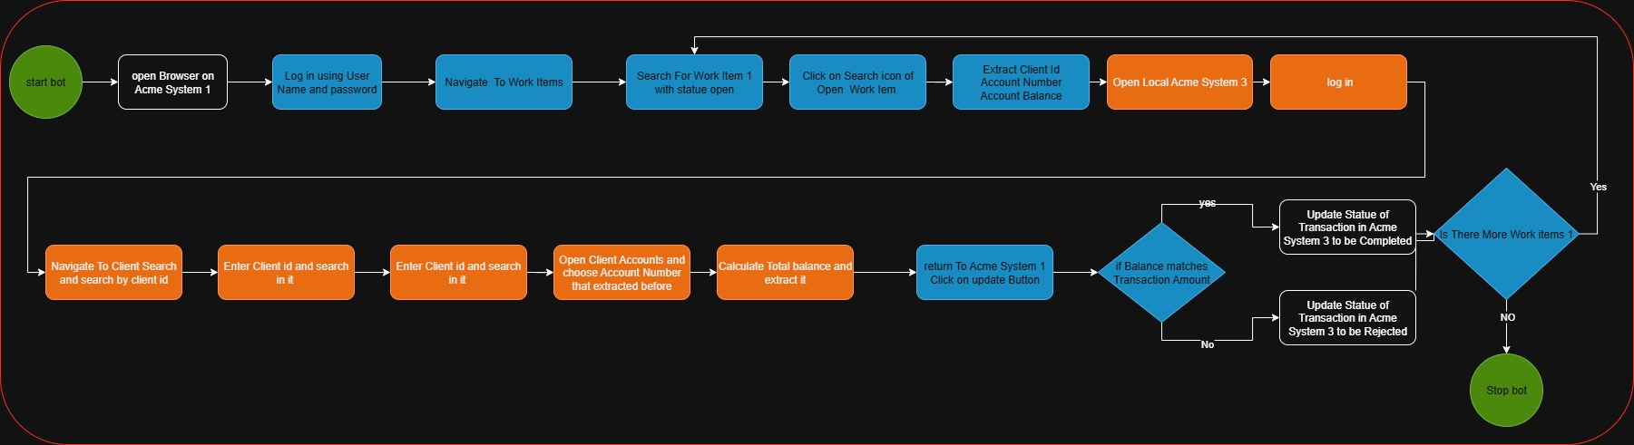

Proposed Automated Solution (To-Be)
The core processing steps will be fully automated.Exceptions will be flagged and routed to a manual exception handling queue for review by an AP clerk .

In Scope

The table below shows the high-level steps that are in scope for the automation.

Process step | Comments
Log in Acme System 1 | As -is AP must log in to the System with username and password  To-be: This would be done using automation the solution
Search for Work Item 1 and extract Client id | As -is navigates to the Work Items page, applies a filter for WI1, and manually opens each item to copy the Client ID  To- be: The bot will automatically filter WI1, loop through items, and extract the Client ID into a data structure
Open Local Acme System 3 and log in | As-Is: AP opens ACME System 3 (desktop app/web), enters login details, and waits for the system to load.  To-Be: The bot will open System 3, handle login with secure credentials, and navigate to the accounts module automatically.
Search for client Account by id | As-Is: AP types in the Client ID into the search field and retrieves the client account.  To-Be: The bot will use the Client ID from System 1, search the account in System 3, and open it without human input.
Calculate all previous balance transaction | As-Is: AP reviews account transactions manually and calculates the balance with a calculator or spreadsheet.  To-Be: The bot will extract all transactions, sum them up, and determine the current balance automatically.
Update current Transaction mark it as completed or rejected | As-Is: AP goes back to System 1, updates the transaction status.  To-Be: The bot will update WI1 with the balance or rejection reason and set the status accordingly.

Out of Scope

There are no activities out of scope for RPA

Detailed Process Map
Step | Short Description
1 | Access ACME System 1
1.1 | Open the ACME System 1 Web Application
1.2 | Enter Username and Password
1.3 | Navigate to the Work Items section
1.4 | Search for Work Items 1
1.5 | Open the first WI1 item in the list
1.6 | Extract Client ID (and other details if required)
2 | Access ACME System 2
2.1 | Open the Local ACME System 3 Application
2.2 | Enter Username and Password and login
2.3 | Navigate to the Client Accounts module
2.4 | Enter the extracted Client ID into the search field
2.5 | Open the Client Account details page
2.6 | Extract all historical transactions
2.7 | Calculate the total previous balance
2.8 | Verify the current account balance
2.9 | Record the calculated balance for reporting
3 | Return Access ACME System 1
3.1 | Press on update button
3.2 | Change the Status of WI1 to Completed or Rejected
3.3 | Save and confirm the update
4 | Repeat Process
4.1 | Move to the next WI1 item in System 1
4.2 | Repeat Steps 1.4 →3.3 until all WI1 items are processed

Detailed Process Steps
Step | Step Action Description | Screen Shot |  | Expected result | Remarks
1 | Access ACME System 1
1.1 | Open ACME System 1 on web browser |  | ACME System 1 home screen is displayed |  | Possible exception:  #AE01
1.2 | Enter Username and Password, then click Login | 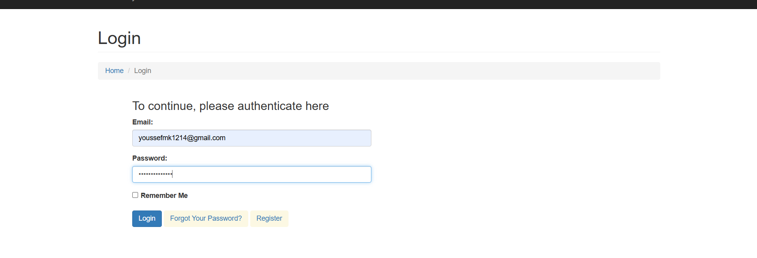 | Access to the dashboard |  | Possible exception: #AE02
1.3 | Navigate to Work Items page | 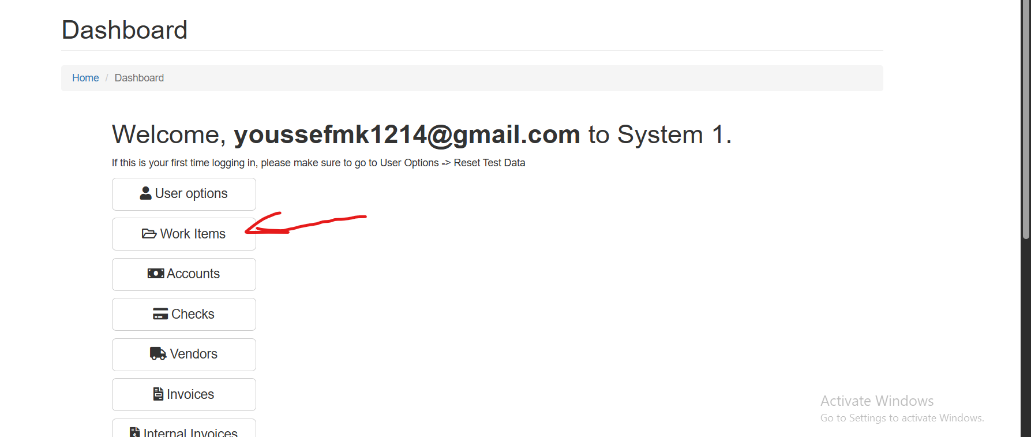 | Work Items list is displayed  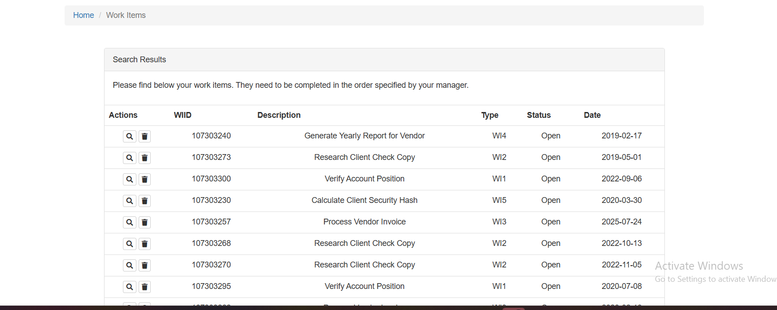 |  | Possible exception: #BE03
1.4 | Search for Work Items 1 | 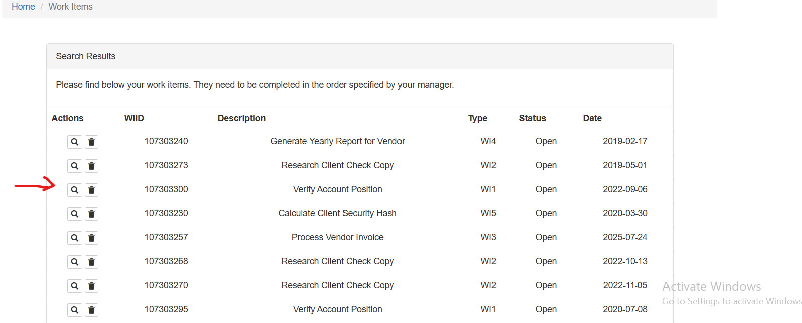 |  |  | Possible exception: #BE01
1.5 | Open work item for each WI1 in pages |  |  | 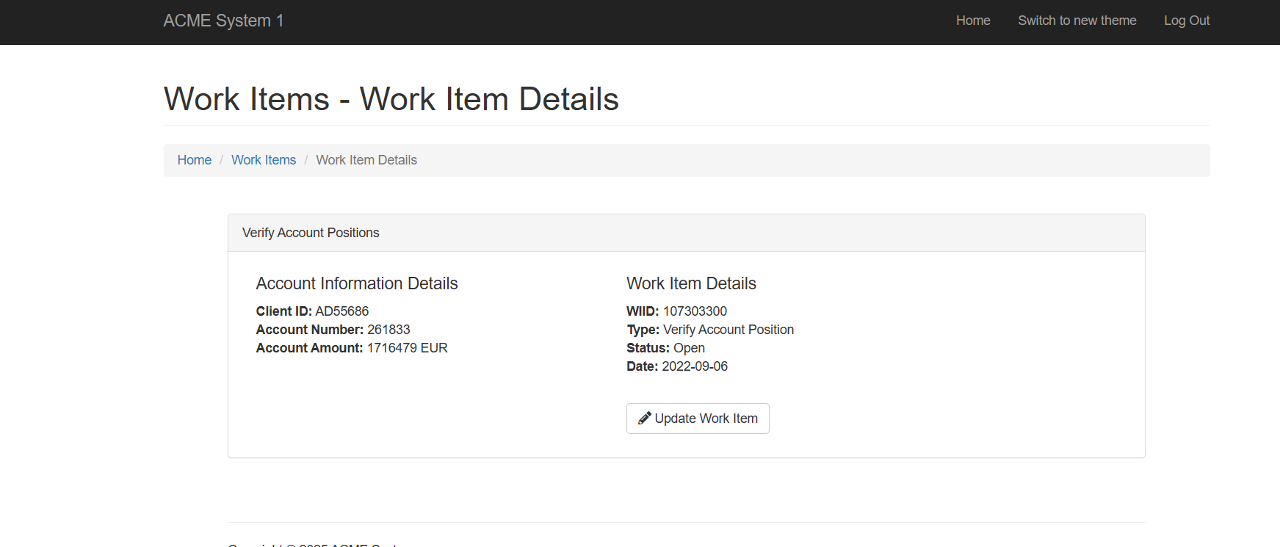 | Possible exception: #BE04
1.6 | Extract Client ID ,Account Number,Account Amount | 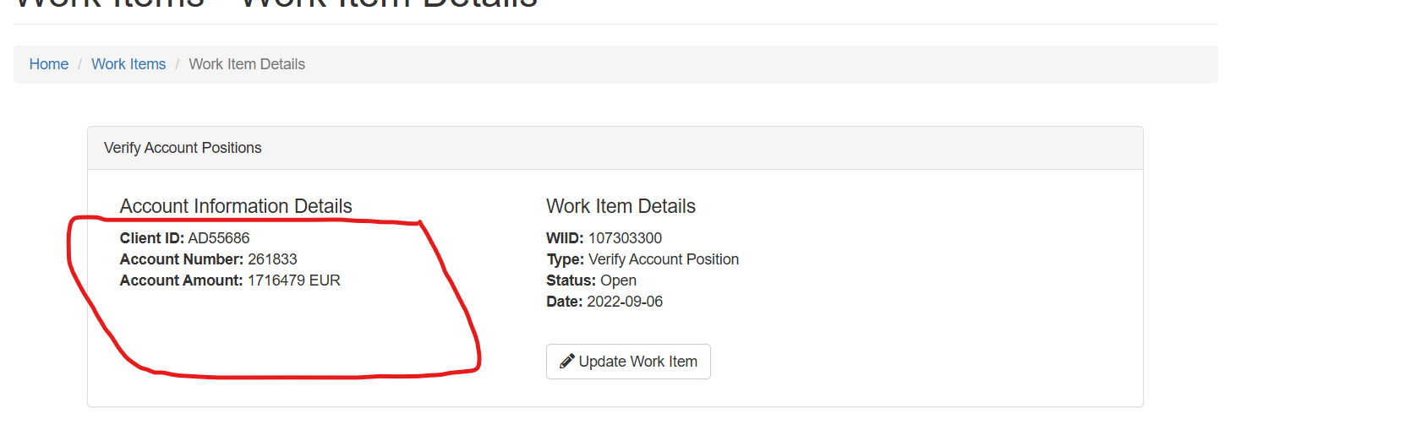
2 | Access ACME System 2
2.1 | Open the Local ACME System 3 Application | 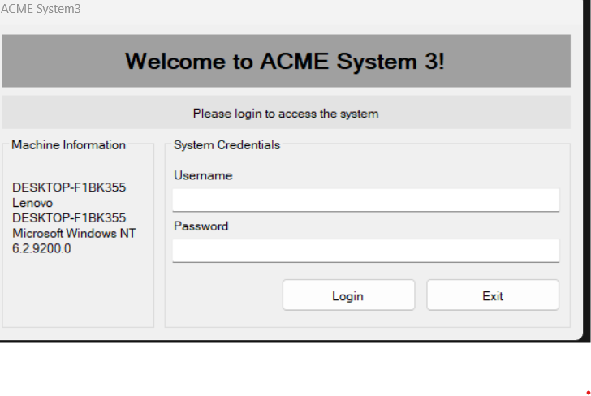 |  |  | Possible exception: - Handle exception if Application Don’t open
2.2 | Enter Username and Password and log in | 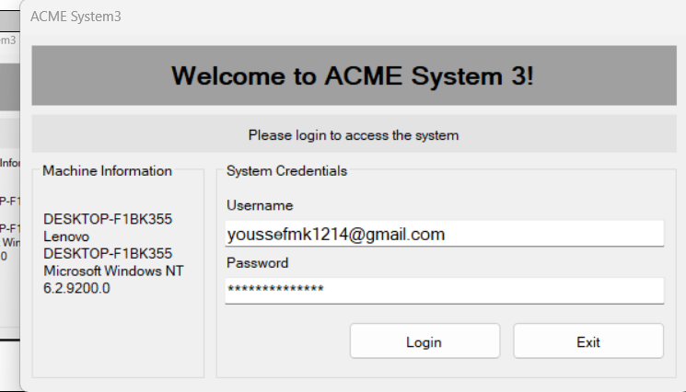 |  | 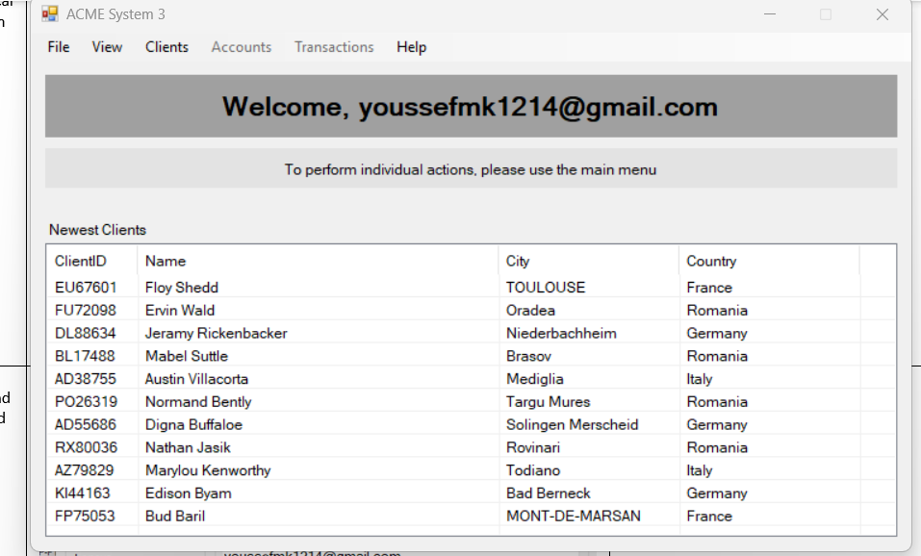 | Possible exception: - Handle exception if  Incorrect email or Password
2.3 | Navigate to the Client Accounts module | 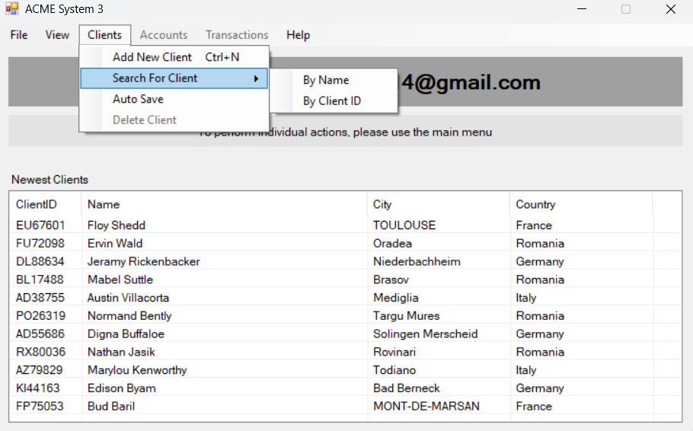
2.4 | Enter the extracted Client ID into the search field and check Include inactive (box) | 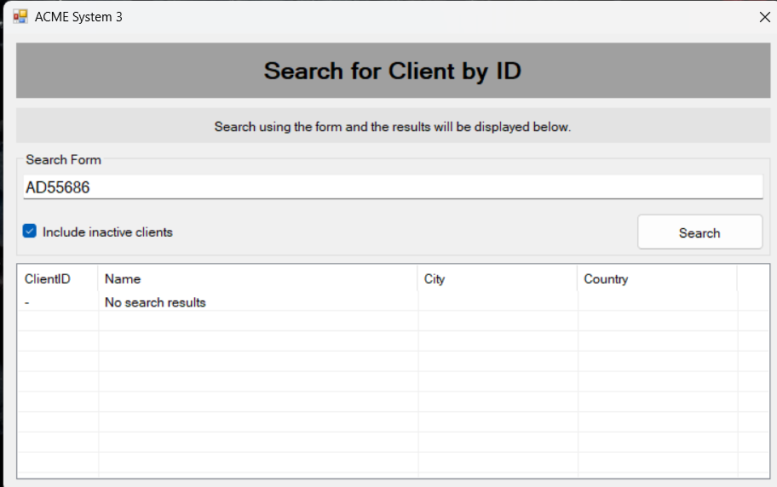 |  | 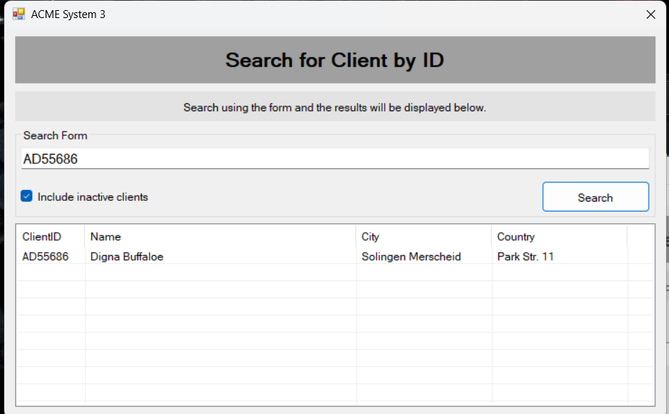 | Possible exception: - Handle exception if  No Client Account Found
2.5 | Open the Client Account details page | 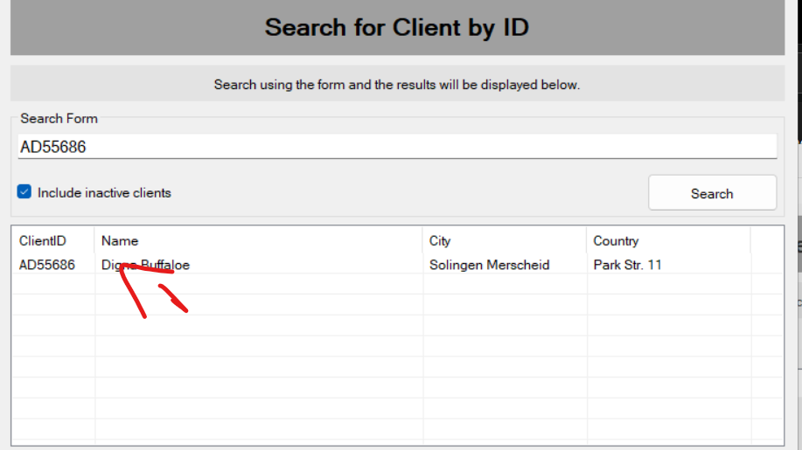 |  | 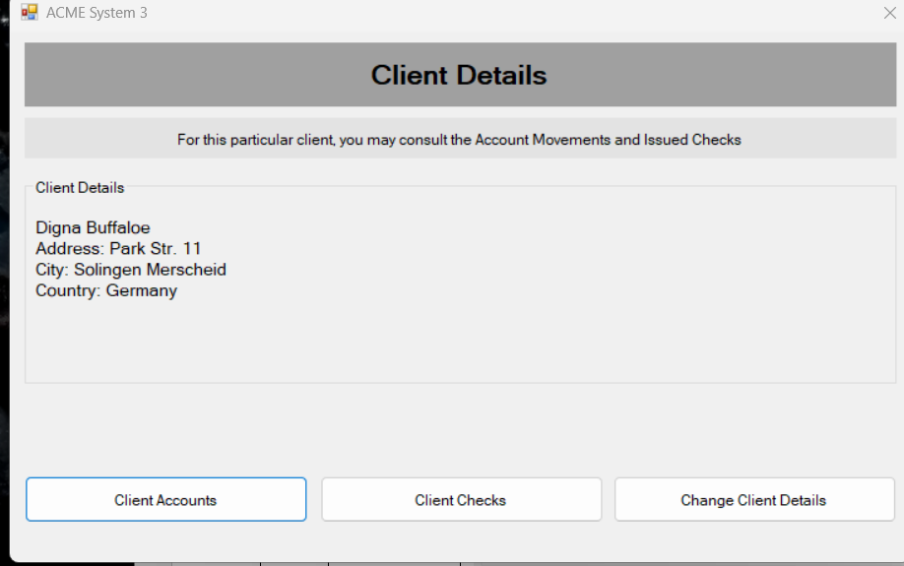
2.6 | Click on Client Accounts | 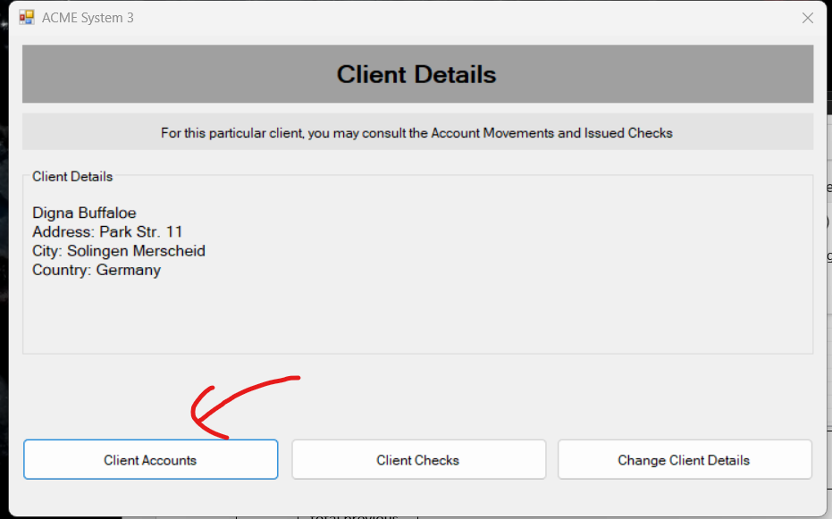 |  | 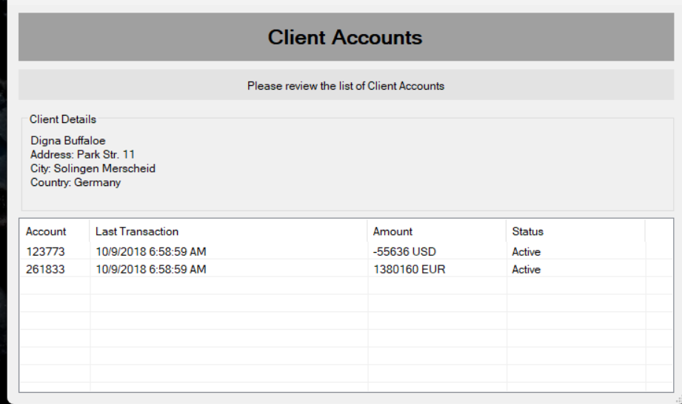
2.7 | Choose Account Number that matches extracted Account Number | 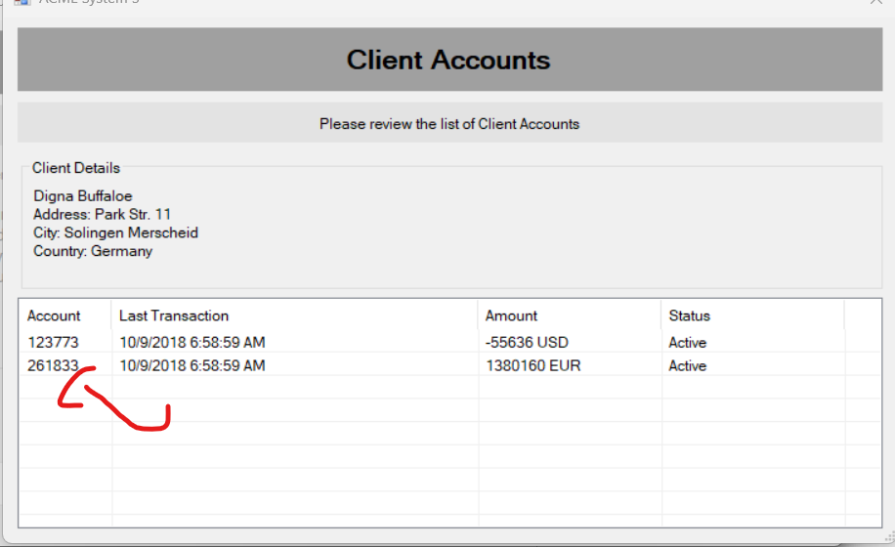
2.8 | Click on show all Button | 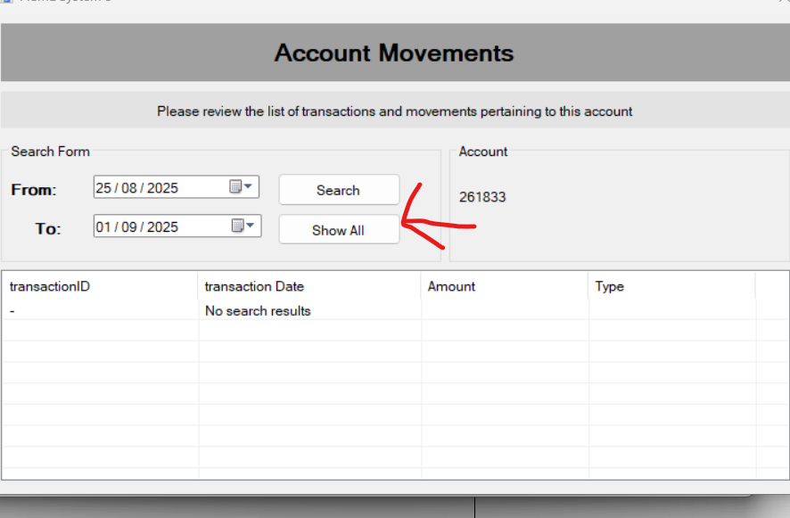
2.9 | Calculate and extract Total Balance from all Amounts | 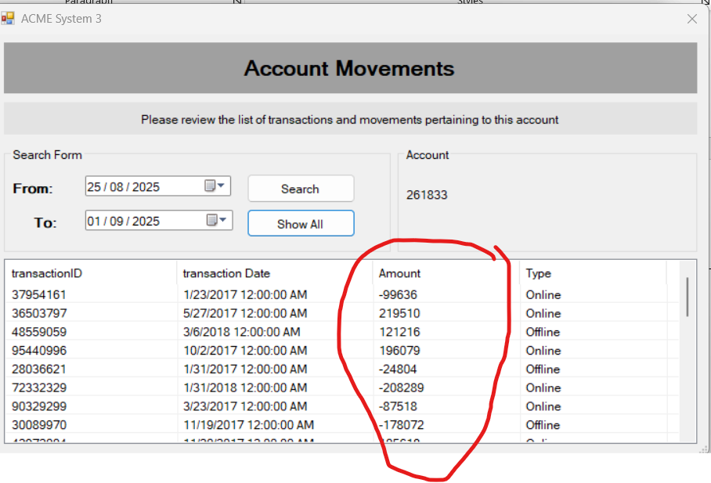
3 | Return Access ACME System 1
3.1 | Press on update button | 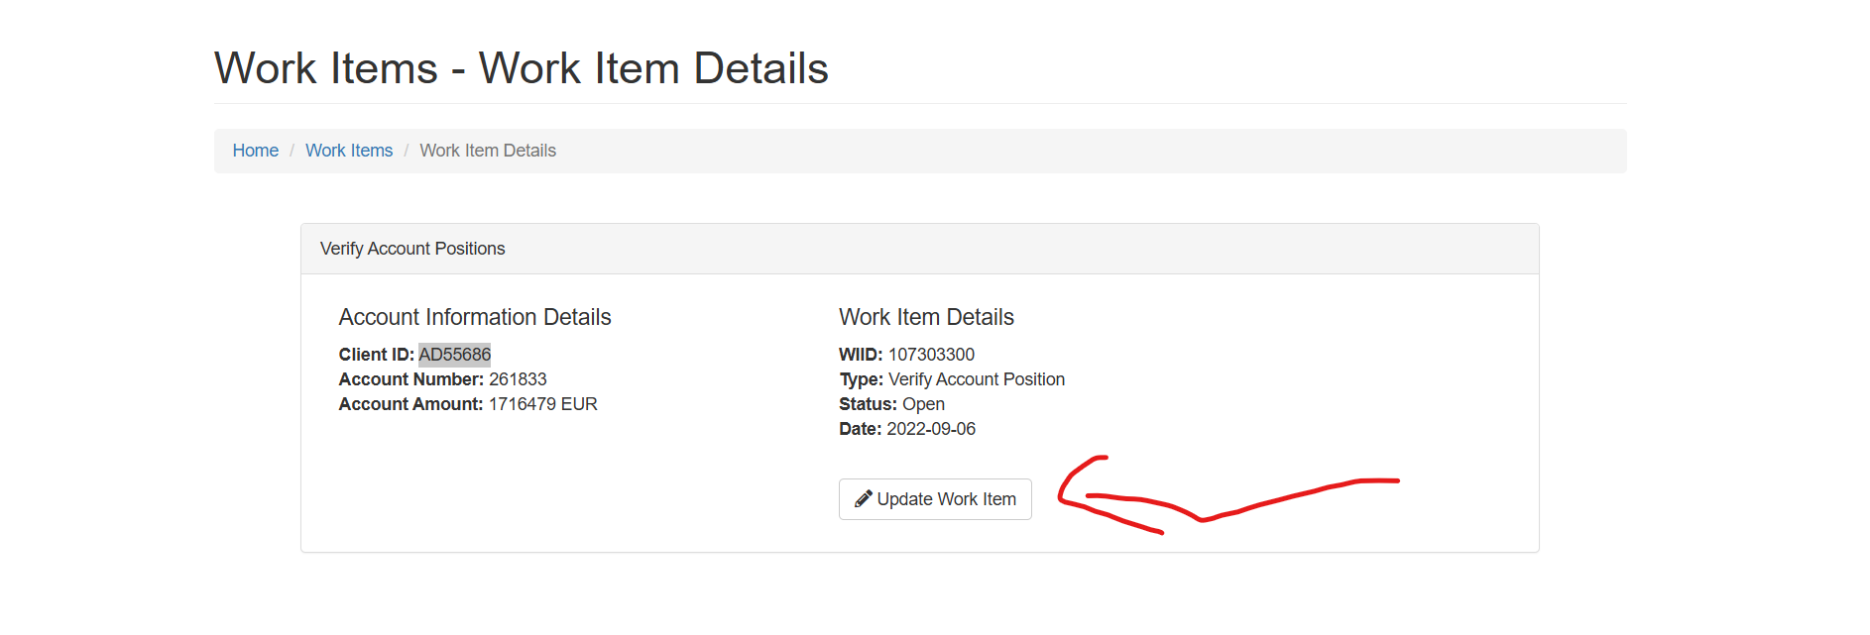 |  | 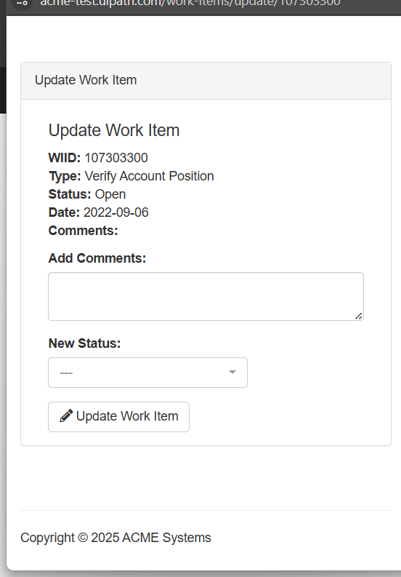
3.2 | Check if Total Balance Extracted Matches All Amounts or not
3.3 yes | Change the Status of WI1 to Completed | 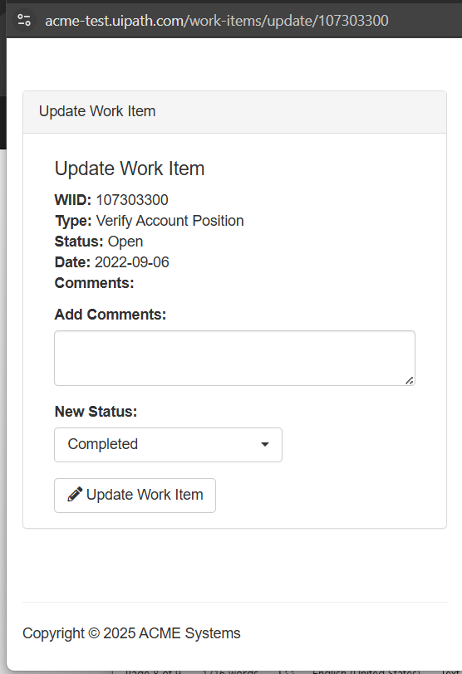
3.3 no | Change the Status of WI1 to Rejected | 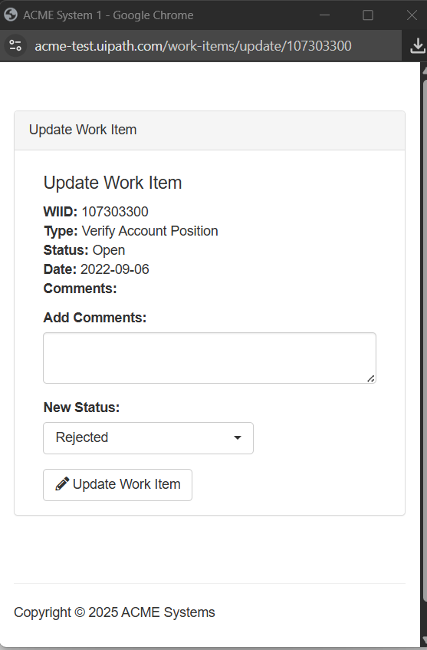
3.4 | Save and confirm the update | 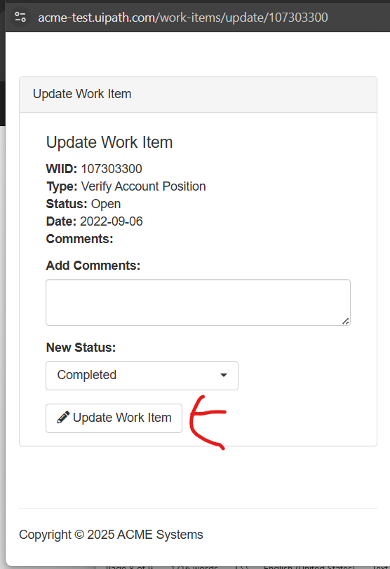
4 | Repeat Process
4.1 | Move to the next WI1 item in System 1
4.2 | Repeat Steps 1.4 → 4 until all WI1 items are processed

Exceptions

9.1. Business Exception

Exception Name | Description | Action to be taken
#BE01 no task of type ‘Process Transaction’ exist in all pages | If you open work items list and there no work item 1 with statue open | Wait for 30 minutes and send email to project Manager
#BE02 No Client Account Found | If you open and search with client id and nothing, come out of search | Update Transaction to be marked rejected and escalate to Project Manager and Director of Accounting
#BE03 No Work Items found | After opened Work Item dashboard and there nothing work Items found | Stop updating Transaction and terminate process and escalate to Project Manager and Director of Accounting
#BE04 no task of type ‘Process Transaction’ exist in this page | If in current page there no Work item 1 with statue open | I should move to next page

9.1. Application Exception

Exception Name | Description | Action to be taken
#AE01 Acme System 3 don’t open | if Application Don’t open | Retry 3 times if not opened Stop updating Transaction and terminate process and escalate to Project Manager and Director of Accounting
#AE02 Can’t log in | If I enter user email and password doesn’t have a Home page | Retry 3 times if not opened Stop updating Transaction and terminate process and escalate to Project Manager and Director of Accounting

Non-process requirements

9.1. Systems

System | Usage | Frequency
Acme System 1 | To Get Transactions and update it | In every transaction
Acme System 3 | To Get Balance of Client Account info

9.2. Reporting
Currently, no reports are issued from this process. However, we would like the automated solution to provide us with the option of creating basic report structures. This basic reporting will include identifying the status of client Account and the overall Transactions of the Account. This will give individual Finance and Accounting Managers and the wider business greater insight to make informed decisions.

9.3. Archiving
All information (Client Account) is currently stored in the Acme System 3. Going forward, as this is being automatically sent to the new automated solution, it will exist there.

9.4. Security & data retention
The automated solution will be sending, processing and storing sensitive and confidential information. It may also need to have direct feeds to Balance Transactions if not today, then in the future). Given this, strong controls will need to be built into the process, the automated solution, any integrations, documentation etc. to make sure there is no breach of confidentiality or security.

Appendix

For security reasons, all documents related to this work are stored HERE and can be accessed using a separately provided password. To gain access to this password, please contact the Project Manager.

Escalations

For immediate contacts for the process automation project, kindly contact the respective contact on the table below:

Email Address | Roles | Responsibilities
robertchapman@company.com | Project Manager | If any blockers come up which stop the progress of the work
Harpreetsethi@company.com | Project Sponsor & Director of Accounting | For queries on budget & resource requirements / challenges
youssefmk1214@rayarpa.com | Business Analyst | Further clarification on process, business rules & scope of activities

